Flare Workshop 5: Creating links

# Linking topics with cross references

For working with cross references, you will need to open your Flare TCOM project and open the **EWU _ MAEnglish_ RTC.html** file in the **A_Introduction Topics** folder.

## To add a cross reference

1. In the second paragraph of the *What will I study* section, change “program requirements” to “course requirements.”
   1. For current information about ~~program~~ ***course*** requirements, please see current EWU Catalog.
2. Insert a new paragraph and type: *For other program requirements see*
3. Position your cursor after “see.”
4. Select **Insert>Cross Reference**. Insert Cross Reference dialog box appears.
5. In the **Link to** section, select **Topic in Project**.
6. Select the **Intern_descript.htm** file from **C_Internship Topics** folder
7. In the **Target Frame** drop-down, select **New Window/Tab.**
8. In **Screen Tip** text box type: *A link to information about internships*.
9. Click OK
10. Delete the next two paragraphs
11. SAVE

# Linking within a topic (bookmarks)

## To add a Bookmark

1. 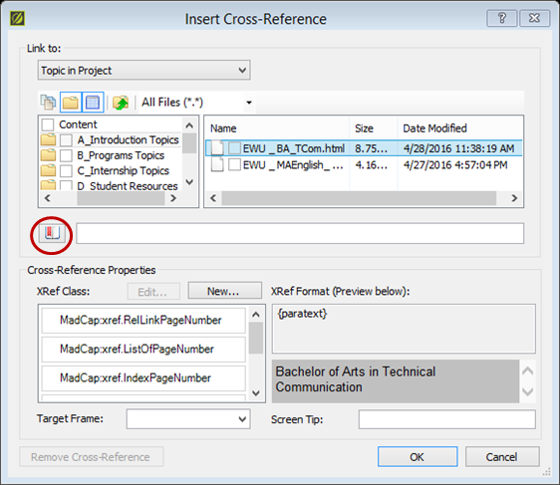In the SettingUpIntern.htm topic, at the end of the first paragraph, type: *For types of positions see*
2. With your cursor positioned after “see, ” select **Insert>Cross Reference**. Insert Cross Reference dialog box appears.
3. In the **Link to** section, select **Topic in Project**.
4. Select the **Intern_descript.htm** Topic file.
5. Click the **Bookmark** button. The /select Bookmark dialog box appears.
6. Select **Headings>h2 What could I do with my degree**.
7. In the **Target Frame** drop-down, select **New Window/Tab.**
8. In **Screen Tip** text box type: *A link to information about internship positions titles*.
9. Click OK
10. SAVE

## Practice

Insert two more cross references:

* 1. Enter a comma after the first cross reference, and create a cross reference to the **RTC Research Thesis.htm** topic.
  2. Enter a comma and “and” after the second cross reference, and add a third cross reference to **RTC Professional Project.htm** topic.
  3. SAVE
  4. Preview the topic to test the cross references.

# Linking to a document

In addition to linking to topics you can also link to other documents or file types, including HTML, XML, Microsoft Office, and PDF files.

For this exercise you will need to download two files from Canvas:

* 2yearplanSCHEDULE_TC_VCD-PR
* RTC_FactSheet_2016.pdf

**Save these files to your TCom Flare project>Content folder**

## To link to a document

1. Open the EWU _ MAEnglish_ RTC.html topic
2. Insert a new paragraph at the end to the topic.
3. Type: *For information, see the RTC fact sheet*.
4. Select the text: *RTC fact sheet*
5. Select **Insert>Hyperlink** or click in the XML editor toolbar
6. In the **Link to** section, select **File in Project**.
7. Select **All Files** in the files drop-down box.
8. Select the **RTC_FactSheet_2016.pdf** file.
9. In **Screen Tip** textbox type: *A link to a PDF document with admission and program requirements.*
10. For **Target Frame**, select **New Window**
11. Click **OK**
12. SAVE

## Practice

In the **EWU _ BA_TCom.html** topic, in the Emphasis and Concentration section add a link to the **2yearplanSCHEDULE_TC_VCD-PR** using the Graphic design and PR option as the linking text.

# Linking to website

## To add a link for a website:

1. In the **SettingUpIntern.htm** topic, select **Career Center Internship Office**.
2. Select **Insert>Hyperlink.**
3. In the **Link to** section, select **Website.**
4. Type a website address for Career services Jobs and Internships page. (<http://www.ewu.edu/community/career-services/students-and-alumni/jobs-and-internships>) If needed, Flare will add the “http://” to your URL
5. In **Screen Tip**, type a link to career services web page for internships.
6. For **Target Frame**, select **New Window**.
7. Click **OK**
8. Save

## Practice

In the **SettingUpIntern.htm** topic, create a link to the online Special Course Approval/Registration Form.

# Viewing links

You can view all the links related to a topic in the Link Viewer.

## To view links

1. Select **View>Link Viewer**. The Link Viewer window appears.
2. Open a topic in the XML Editor.

# Building a glossary

The Glossary is located in a folder in the Project Organizer.

## To add terms to the glossary

1. 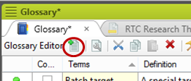Open the project glossary. The **Glossary Editor** will appear.
2. Click the **New Item** button in the Glossary Editor. The Properties dialog box will appear.
3. Type “Internship” for the term.
4. Type definition: *An internship is a temporary position in a workplace with an emphasis on on-the-job training rather than merely employment, and it can be paid or unpaid. It requires 200 hours for five academic credits.*
5. Select **Stem words to include term variants in automatic link creation** and **Ignore case in automatic link creation**.
6. Select **Update matching glossary term links and save glossary**.
7. Select **Style** tab.
8. Select **Popup**. NOTE: It is best to change in the style sheet.
9. Click OK.

## Practice

Add the following terms and definitions to the glossary:

Thesis

A 20-30 page article of publishable quality that effectively and persuasively communicates your research on a topic related to rhetoric or technical communication.

Professional Project

The professional project requires two components: a project and an essay. The project may consist of writing, editing, designing, and producing an online or print document. The essay is a 15-20 page paper detailing goals for the project, research about the theory and practice that inform the genre, and a critical analysis of how the concepts, principles, and theories from the research inform the writing and design of the document.